

Installation GUIDE
Version 4.3.2

Isabelle LECOMTE

March 2025

Hi-sAFe is a model included in Capsis platform, there is no stand-alone version available.
This documentation is related to Capsis installation from an installer, either downloaded from the Hi-sAFe download page or provided by a Hi-sAFe modeller.
Hi-sAFe may be installed with the same installer on machines under Windows, Linux or Mac OS X.
In case of trouble during the installation, have a look at the Capsis FAQ :
http://capsis.cirad.fr/capsis/documentation/faq

Ensure java 1.8 for 64bit is installed on your computer
Capsis is developed for Java 1.8, if you have a more recent version, some problems can occur. To check the correct version of Java is installed and available, open a Terminal and check the answer to this command java –version

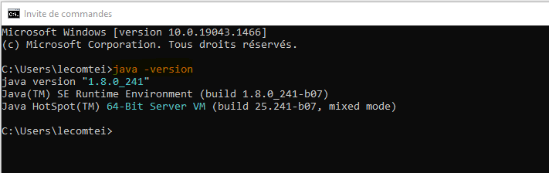
If java is not found on your system or the version is not 1.8.x, please download and install the correct version of java for your operating system, if you have a 64bit PC install a 64bit java version!
For Windows and Linux: install JRE from
https://www.java.com/fr/download/

For Linux: install JRE from
https://java.com/fr/download/help/linux_x64_install.html
For MacOS: install JRE from
https://www.java.com/en/download/apple.jsp

Install from setup JAR file
The jar file contains only executable version of Hi-sAFe, there is no source code included.

On Windows and Mac, run the installer (hisafe-setup-4.3.2.jar) by double clicking on it and follow the install instructions.

#under Linux
cd directory-where-jar-is-located
java –jar hisafe-setup-4.3.2.jar

Follow the installation instructions.

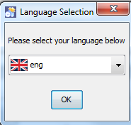
On step 4: Choose a target path

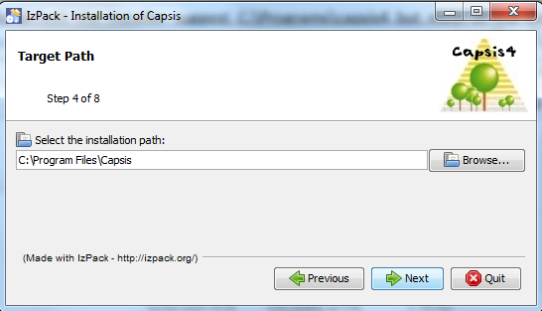

By default on a Windows operating system, the installer suggests C:\Program Files\Capsis but most of the time you will not have write privileges for this. Best advice is to create a new folder named C:\ capsis4 or D:\ capsis4.
On Mac and Linux, such advice can be followed. Default installation paths are respectively /Applications/Capsis and /home/username/Capsis, but other directories can be chosen. Just make sure you have the right permissions on it.
The minimum required size is 160 Mo.
On step 7, desktop shortcuts will be created. Most of the time this step does not work and you will have to stop the installation here by closing the window. Installation is DONE!

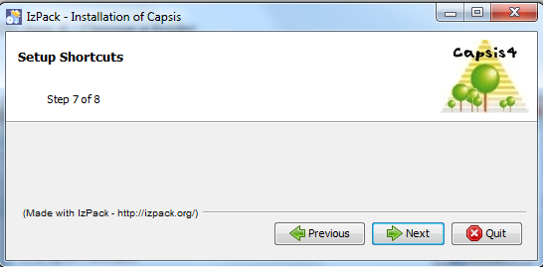

Install from GITHUB source code
Capsis and Hi-sAFe are both under GNU licence. JAVA source code can be downloaded on the GitHub repository: https://github.com/hisafe/hisafe.

Capsis and Hi-sAFe source code has to be recompiled so you need to install JDK (Java Developer Kit) version 8.

https://www.oracle.com/java/technologies/javase/javase8-archive-downloads.html

#under windows
cd capsis4
ant clean compile

#under Linux / Mac OS X
cd capsis4
sudo apt-get install openjdk-8-jdk
sh ant clean compile

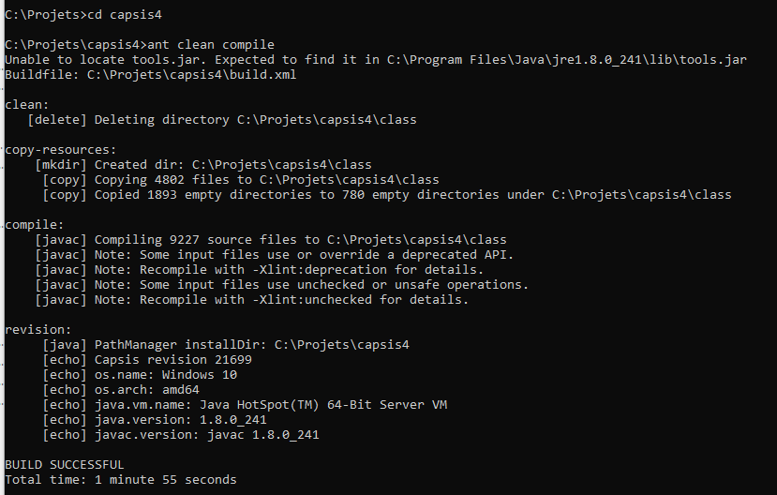

Increase Capsis running memory
- Open a windows terminal
- Go to the Capsis installation path with CD command
- Run the command SETMEN with the RAM you want to assign to the Capsis execution (1024 – 2048 – 4096 etc…)

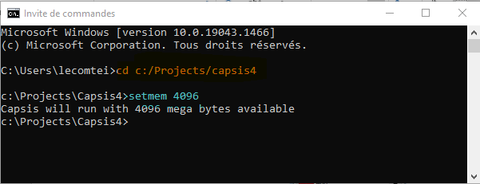

Run Hi-sAFe

To check Hi-sAFe is correctly installed, you can run a simple example provided with the model.

Open a terminal and execute the following commands:

#under windows
cd capsis4
capsis -p script safe.pgms.ScriptGen C:/capsis4/data/safe/simSettings/exemple/exemple.sim

#under Linux / Mac OS X
cd capsis4
sh capsis.sh –p script safe.pgms.ScriptGen C:/capsis4/data/safe/simSettings/exemple/exemple.sim

Replace Capsis4 by your own directory path
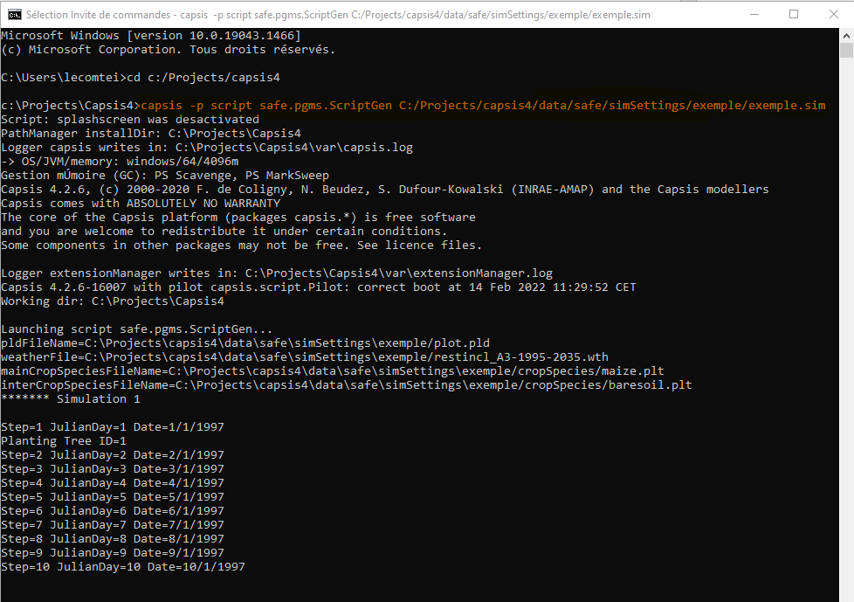

Common issues

No installation rights
If you do not have administration rights to install new software on your computer, you have to ask your administration to grant you the rights to do it.

Wrong version of JAVA
Check you have the 64bit JRE installed (not 32 bit)
Type java – version
The answer has to be

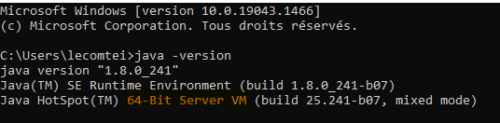

Wrong path for running Hi-sAFe
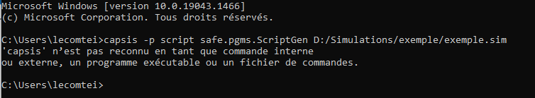

Go to the capsis4 folder installation folder before running Hi-sAFe
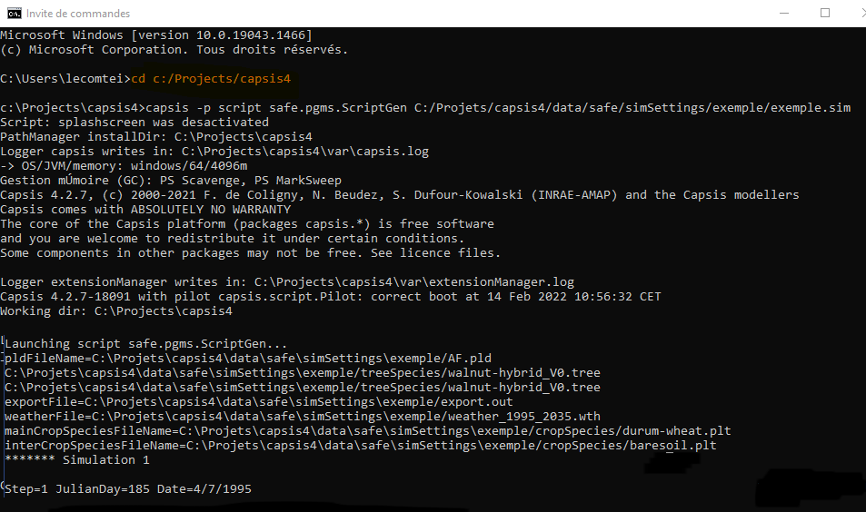

Wrong simulation file name
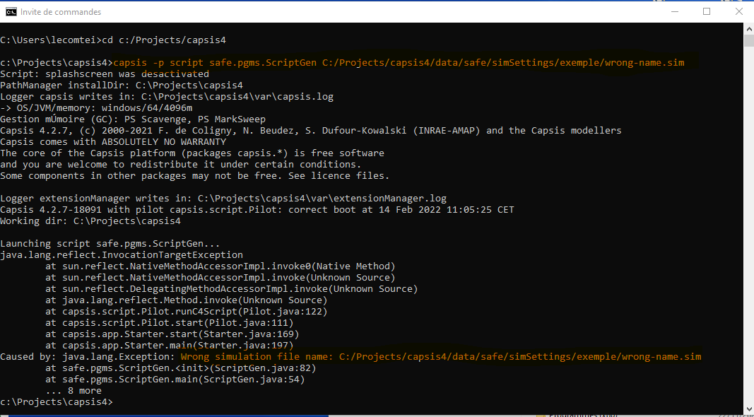

Check the path you type is the right one, the name of the folders and sim file are correctly spell, and that there is no white spaces or forbidden characters in the folder names and sim file names.

Missing parameter or initialization issue
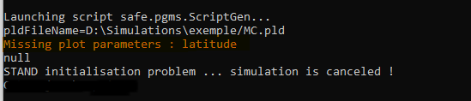

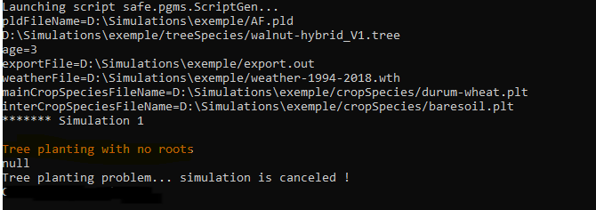

Correct the problem and run again

More documentation
For more documentation and information about Hi-sAFe:
https://www1.montpellier.inra.fr/wp-inra/hi-safe/en/
https://github.com/hisafe/hisafe/tree/master/doc

